UML Deployment Diagram — ISU Infirmary Logbook Management and Health Surveillance System
Nov 4, 2026 · @cj
The system runs on one Infirmary Server PC inside the University Health Service LAN; nurses use it from their own browsers, and only password-reset emails leave the campus network.

Submission details
Item | Details
Course | DSA414 — Software Engineering I
Activity | Remote Task: UML Deployment Diagram
Project | ISU Infirmary Logbook Management and Health Surveillance System
Students | 1. Cyrille Jef N. Gaffud (Leader) · 2. Dj Jaziel P. Nicolas
Section | ________
Date submitted | November 4, 2026
Video file name | YOURSECTION_GAFFUD_FINAL_ACT1
Reference used: GeeksforGeeks — Deployment Diagram (UML).

Deployment diagram
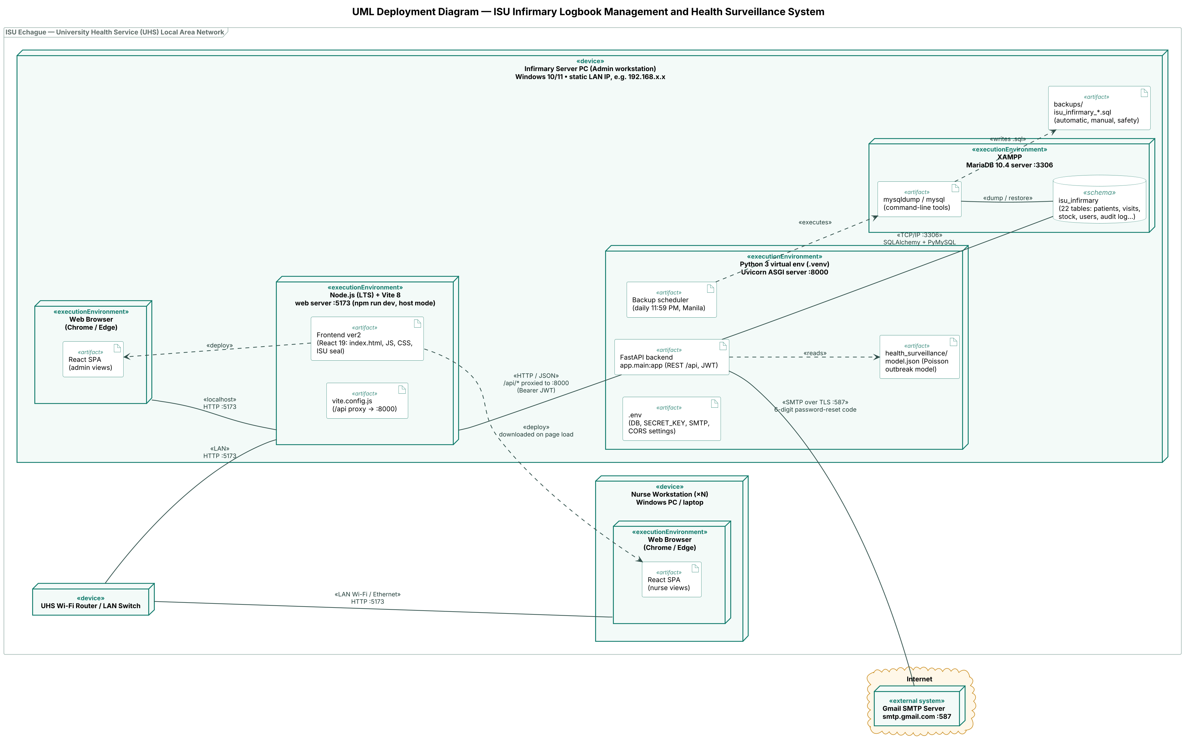
Three-dimensional boxes are nodes («device» hardware and «executionEnvironment» software platforms), document icons are «artifact»s, solid lines are communication paths labelled with their protocol and port, and dashed arrows are dependencies or «deploy» relationships.

Deployment nodes
Four nodes make up the system: one server PC, any number of nurse workstations, the LAN router that joins them, and Gmail's mail server on the internet.
Node | Stereotype | Hardware / OS | Role
Infirmary Server PC (Admin workstation) | «device» | Windows 10/11 PC or laptop in the UHS office, static LAN IP (e.g. 192.168.x.x) | Hosts the database, backend API, web server and backups; the admin also signs in here
Nurse Workstation (×N) | «device» | Any Windows PC or laptop on the UHS network | Nurses on duty record visits, patients, stock and see outbreak alerts in a browser
UHS Wi-Fi Router / LAN Switch | «device» | The clinic's existing router | Connects the workstations to the server; no internet needed for normal use
Gmail SMTP Server | «external system» | smtp.gmail.com, on the internet | Sends the 6-digit code for Forgot password

Execution environments
Four software platforms run inside the server PC; each nurse workstation runs only a web browser.
Execution environment | Runs on | Listens on | Hosts
XAMPP — MariaDB 10.4 server | Infirmary Server PC | TCP 3306 (local) | The isu_infirmary database and the mysqldump / mysql tools
Python 3 virtual environment (.venv) with Uvicorn ASGI server | Infirmary Server PC | HTTP 8000 (local) | The FastAPI backend, the health-surveillance model, the backup scheduler, .env
Node.js (LTS) with Vite 8 web server, started with npm run dev -- --host | Infirmary Server PC | HTTP 5173 (LAN) | The React frontend (Frontend ver2) and the /api proxy
Web browser (Chrome / Edge) | Server PC and every nurse workstation | — | The React single-page app, loaded from port 5173

Software artifacts
Artifact | Deployed on | What it is / does
Frontend ver2 (React 19: index.html, JS, CSS, ISU seal) | Vite web server | The user interface: dashboards, patient records, stock, Reports (Analytics and Tables), user management, audit log, settings
React SPA (nurse views / admin views) | Each web browser | The same frontend after it is downloaded; the account's role decides which dashboard and menu it shows
vite.config.js | Vite web server | Forwards every /api/... request from the browser to the backend on port 8000
FastAPI backend (app.main:app) | Uvicorn (Python .venv) | REST API under /api: sign-in with JWT tokens, patients, visits, stock, users, reports, audit log, backups, trash, maintenance mode
health_surveillance/model.json | Uvicorn (Python .venv) | The trained Poisson outbreak model; the backend reads it to compare this week's cases per college and illness with the normal level
Backup scheduler | Uvicorn (Python .venv) | Runs inside the backend; takes the automatic backup every day at 11:59 PM (Asia/Manila)
.env | Uvicorn (Python .venv) | Settings kept off GitHub: database login, SECRET_KEY, Gmail app password, allowed origins
isu_infirmary database (22 tables) | MariaDB server | All records: patients, visits, complaints, medicines and supplies, stock requests, users, audit log, settings
mysqldump / mysql | MariaDB server (XAMPP) | Command-line tools the backend runs to create and restore backups and the Export .SQL file
backups/isu_infirmary_*.sql | Server PC file system | Automatic, manual and pre-restore safety backups, kept for restore from Settings

Communication paths
Every path except the Gmail one stays inside the UHS LAN or inside the server PC itself.
From | To | Protocol / port | What travels
Nurse browser | Router → Vite web server | HTTP over LAN (Wi-Fi or Ethernet), port 5173 | The web pages, then every /api call
Admin browser | Vite web server | HTTP on localhost, port 5173 | Same as above, on the server PC itself
Vite web server | FastAPI backend | HTTP / JSON on localhost, port 8000 (/api/* proxy) | Requests with a Bearer JWT token; JSON replies
FastAPI backend | MariaDB | TCP/IP, port 3306 (SQLAlchemy + PyMySQL) | SQL queries and transactions
Backup scheduler | mysqldump / mysql | Local process call | Dump and restore of the database
mysqldump | backups/ folder | Local file write | .sql backup files
FastAPI backend | Gmail SMTP server | SMTP over TLS, port 587 (internet) | The 6-digit password-reset code email

Deployment relationships
In the diagram, an artifact drawn inside a node is deployed on that node; the dashed arrows add the rest.
- Frontend ver2 «deploy» React SPA: the browser downloads the frontend from the Vite server on page load, so the same build becomes the nurse views on each workstation and the admin views on the server PC.
- FastAPI backend «reads» model.json: the outbreak model is loaded by the backend; it is not a separate service.
- Backup scheduler «executes» mysqldump / mysql: backups and restores use XAMPP's own tools against the live database.
- mysqldump «writes» backups/: each dump is saved as a .sql file on the server PC's disk.
- Nesting: the backend, model, scheduler and .env are deployed in the Python environment; the database and dump tools in XAMPP; the frontend and proxy config in Vite; all four environments on the one Infirmary Server PC.

How it runs
A nurse saving a visit shows every part working together:
- The nurse opens http://<server LAN IP>:5173 on a workstation; the Vite server sends the React app to the browser.
- The nurse signs in. The browser posts the username and password to /api/auth/login; Vite forwards it to FastAPI on port 8000, which checks it against the users table in MariaDB and returns a JWT token.
- The nurse fills in Add visit record and saves. The browser sends POST /api/visits with the token; FastAPI writes the visit, its complaints and the medicines given, and lowers the stock, in one database transaction.
- When the dashboard loads, FastAPI reads model.json, counts this week's visits per college and illness in MariaDB, and returns any “Possible outbreak” alert, which the nurse sees as a banner.
- Every day at 11:59 PM the backup scheduler runs mysqldump and saves isu_infirmary_*.sql in backups/; the admin can restore it or export it from Settings.
- Only when someone uses Forgot password does the server reach the internet: FastAPI emails a 6-digit code through Gmail SMTP on port 587.

Justification and consistency with the SRS
The design puts everything on one LAN server because the SRS scopes the system to the UHS clinic's own network, with no cloud hosting.
Design decision | Why | Where it matches the SRS / architecture
One Infirmary Server PC on the UHS LAN | Patient health records stay inside the clinic; works without internet; no hosting cost | LAN-only deployment; data privacy of patient records
Nurses use only a web browser | Nothing to install on each workstation; any PC on the network can be used | Nurse and admin roles share one system; the account decides the dashboard
Three tiers: React frontend → FastAPI REST API → MariaDB | Each layer can be changed or tested on its own; the frontend never touches the database directly | The overall client–server, three-tier architecture
JWT tokens on every /api call; secrets in .env | Only signed-in users reach the data; passwords and keys are not in the code or on GitHub | Sign-in, account lockout, password rules, audit log of every change
MariaDB through XAMPP on port 3306, reached only from the server PC | Free, already used in class, easy to back up with mysqldump | Relational database design (22 tables)
Backup scheduler and backups/ on the same server | Daily automatic backup at 11:59 PM even if nobody clicks; restore and Export .SQL from Settings | Backup and recovery requirements
Outbreak model deployed with the backend | Alerts are computed from the clinic's own visit data and shown to the nurses on duty | Health surveillance (outbreak early warning) feature
Gmail SMTP as the only internet link | Sending the reset code needs email; everything else stays local | Forgot password by email with a 6-digit code
Limits and next step. The single server is one point of failure, so backups should also be copied to a USB drive with Export .SQL. For a permanent deployment, the frontend can be built once with npm run build and served as static files instead of the Vite dev server.

